Gents Measurement Form
PERSONAL INFORMATION
*Full Name:
*Email:
Company
*Country:
*Telephone:
Fax Line:
*Age:
Height:
Weight
*Are you a returning customer?

MEASUREMENT INFORMATION
Unit of Measurement | Centimeters / Inches
  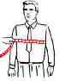
  Chest
  Measure around body well up under arm holes.
  Size:
  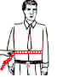
  Stomach
  Measure around stomach line.
  Size:
  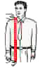
  Length
  Measure from lower collar seam to length desired.
  Size:
  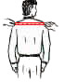
  Full Shoulder
  Measure back at end of shoulders.
  Size:
  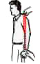
  Sleeves
  Measure sleeves from
  shoulder seem to length desired.
  Size:
  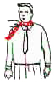
  Neck
  Measure around the neck.
  Size:
  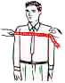
  Front
  Measure from one armhole to other arm hole in front.
  Size:
  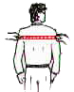
  Back
  Measure from one armpit to other arm pit at back.
  Size:
  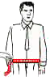
  Waist
  Measure around waist Line.
  Size:
  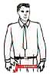
  Hips
  Measure around hips at widest point of seat but not tight.
  Size:
  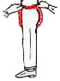
  Crotch
  Measure from center front waist under legs to center back waist.
  Size:
  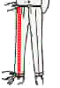
  Length
  Measure from top of waist
  band to bottom of cuff.
  Size:
  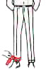
  Cuff
  Measure width around cuff as shown.
  Size:
  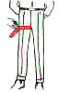
  Thigh
  Measure width around the thigh as shown.
  Size:

Select the pictures nearest to your figure. (Type : Yes)
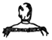 | 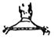 | 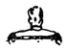
Normal Shoulders Normal Neck | Sloping Shoulders Long Neck | Square Shoulders Short Neck
Select the pictures nearest to your figure. (Type : Yes)
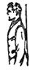 | 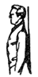 | 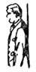 | 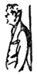 | 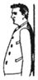
Normal Posture | Erect | Forward Stoop | Forward Stomach | Stout

Bottom of Form

