Women Measurement Form
PERSONAL INFORMATION
*Full Name:
*Email:
Company
*Country:
*Telephone:
Fax Line:
*Age:
Height:
Weight
*Are you a returning customer?

MEASUREMENT INFORMATION
Unit of Measurement |  | Centimeters Inches
  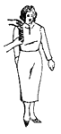
  Shoulder to Bust
  Measure from shoulders seam to bust line
  Size:
  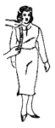
  Front Length
  Measure from shoulder seam to front waist
  Size:
  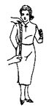
  Jacket Length
  Measure from shoulder seam to jacket length
  Size:
  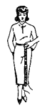
  Skirt Length
  Measure from waist to skirt length
  Size:
  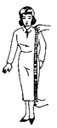
  Top Coat Length
  Measure from shoulder seam to bottom
  Size:
  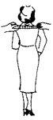
  High Shoulders
  Measure back at end of shoulders
  Size:
  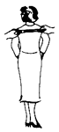
  Low Shoulders
  Measure back centre armhole to other armhole
  Size:
  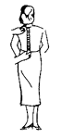
  Back Length
  Measure from centre shoulder to back waist
  Size:
  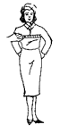
  Bust
  Measure largest part keep tape a little higher at the back
  Size:
  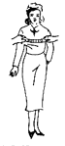
  Bust Width
  Measure the width of bust from one nipple to another
  Size:
  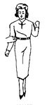
  Waist
  Measure natural waist line
  Size:
  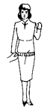
  Hips
  Measure 7" below the waist or widest point of hips
  Size:
  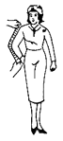
  Sleeves
  Measure from shoulder seam to waist and bend the arm
  Size:
  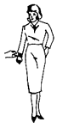
  Cuff
  Measure width around the cuff
  Size:
  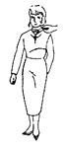
  Neck
  Measure around the neck
  Size:
  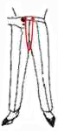
  Trousers "U" Crutch
  From the top of the waistband in front to the top of the waistband in the back
  Size:
  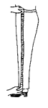
  Slack Out Seam
  Measure from top of waist band to bottom of cuff
  Size:
  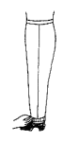
  Slack Cuff
  Measure width around the cuff
  Size:

Select the pictures nearest to your figure.  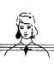 | 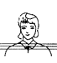 |  | 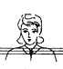
Sloping Shoulder | Regular Shoulder |  | Square Shoulders
Select the pictures nearest to your figure.
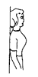 | 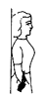 | 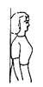
Very Erect | Extreme Hollow Back | Extra Stout

